Orpington Photographic Society outings
Name:

Outing | Potential dates | Can attend this date | Alternative date?
City of London/Barbican centre walk | Sat 19th March
City of London/Barbican centre walk | Sat 9th April
City of London/Barbican centre walk | Sat 23rd April
Kingfisher challenge | TBA
Return to Kelsey park | 9-13 May?
Return to Kelsey park | Other date?
Thames path walk | Sat 21st May
Thames path walk | Sat 28th May
Thames path walk | Sat 11th June
Canary Wharf to Island Gardens walk | Sat 18th June
Canary Wharf to Island Gardens walk | Sat 25th June
Canary Wharf to Island Gardens walk | Sat 20th August
London Canal walk | Sat 2nd July
London Canal walk | Sat 9th July
London Canal walk | Sat 13th Aug
Neasden Temple or Strawberry Hill house | Sat 3rd Sept
Neasden Temple or Strawberry Hill house | Sat 24th Sept
Night time photography | October/  November
Highgate Cemetery | October/November
OPS away days, To discuss please enter some midweek dates that are available, May to September

Railway engineering works checked until end of April.
Bank holidays and peak summer holidays avoided.
Please return to Ian Stedman

Details of the proposed trips
City of London and Barbican centre
A different area to the north of the city of London. The Barbican centre and estate comprise one of the best examples of brutalism architecture in London. Nearby areas of Smithfield or Finsbury could be explored. Plenty of refreshment options.
Duration 2-3 hours, walking distance around 2 miles.
Kingfisher challenge
Titled as a challenge as we may not see them for long. Having been on several outings with the “Surrey Creative Photo group” to find and photo Kingfishers at Ewell, near Epsom I wondered if two small groups would be interested in checking this fairly reliable and local suburban site along a chalk stream at Ewell.
Duration 3-4 hours.
Return to Kelsey Park
A chance to get some more award winning photos of the Herons and other birds at the series of lakes in the park.
Duration 2-3 hours. There is a café on site.
Thames Path walk
Details to be advised, a walk along the river Thames path exploring a less well travelled area of London. Possibly Tower bridge to Wapping, open to other options. There will be opportunities for refreshments.
Duration 2-3 hours, walking distance 2-3 miles.
Canary Wharf to Island Gardens walk
A revised plan from last year, start at Westferry Circus and walk around half the Isle of Dogs to Island Gardens. This covers part of the Thames path.
Duration 2-3 hours, walking distance 2-3 miles.
London Canal/river Walk
Two options under consideration:
1) Regents canal from Limehouse to Victoria Park
2) River Lea from Lea mouth to Olympic stadium
Duration 2-3 hours, distance 2-3 miles.
Neasden Temple or Strawberry Hill
Two options, both rather different for London.
Neasden temple is free to visit, Strawberry hill house admission is £12.50
Duration 1-2 hours + travel time, walking distance 1 mile

Highgate cemetery
Tickets are £4.50 and must be booked in advance as timed entry system is in use.
Would use a self guided visit option to allow us to explore. Ideally a misty day or cloudy skies for mood?
OPS away days
One or two nights away. Location and time to be decided based on interests. We don’t want to try sun-rise photography in June! Most likely in May to September off-season.
Accommodation and dining at members own expense, most likely budget hotel(Premier Inn/Travelodge or local B&B.
Suggestions have been Essex based, ideas from Steve Hedges were:
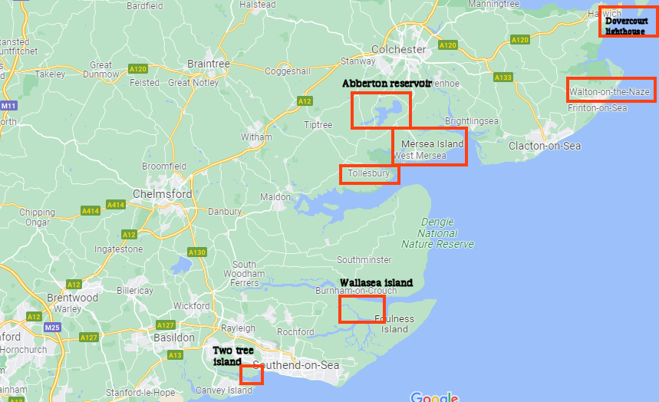

Landscape
Nature
Abberton reservoir
Two tree island
Bluehouse farm
Rainham marshes
Wallasea Island

Tollesbury
Thorpe bay at sun rise
River Chelmer
Mersea Island
Dovercourt lighthouse
Walton-on-the-naze

Other idea was Norfolk. To discuss

